**Report**

Shotan Syrym ITSE-1907

**Rent a car**

At my first job, I made a layout of my website. I visualized the site using Figma. I have set certain examples for the concept.

Now I've done the main page in HTML5 and CSS step by step. First I made a navigation bar (where the city, Payment, Reviews, Promotion, Contacts).

 After that I made the logo as shown here:



Then the search location and contact details. After that, I made another bar where there are the main navigation pages (Services, Fleet, Rental conditions, Price list, categories, Brands)



And we have the main photo where the essence of this site is written on top. + Button for adding detailed information.

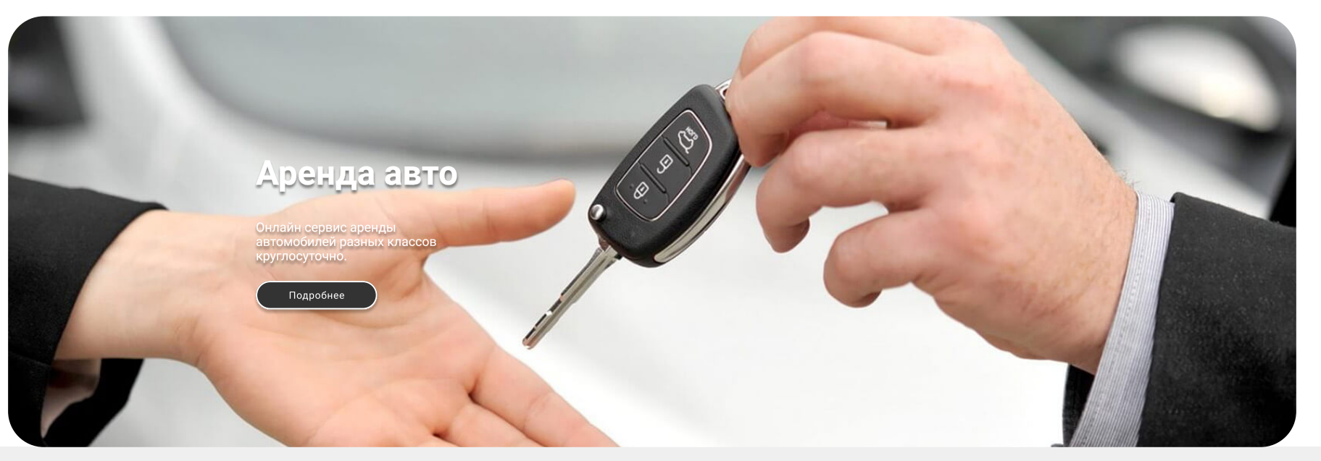

Further down there is a carousel of Special offers. Here is an image of the car and its main characteristics with a daily rental price.

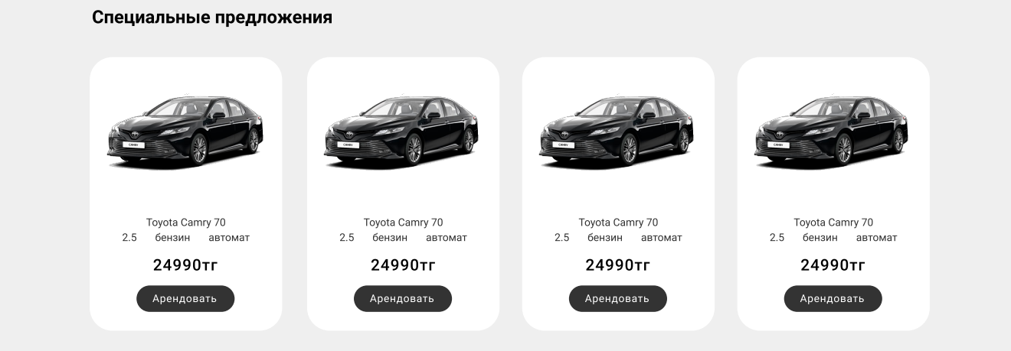

There are two elements at the bottom, the first one is responsible for providing emails, after which it sends news and recommendations to the user.

And the second one will book a car at a certain time.

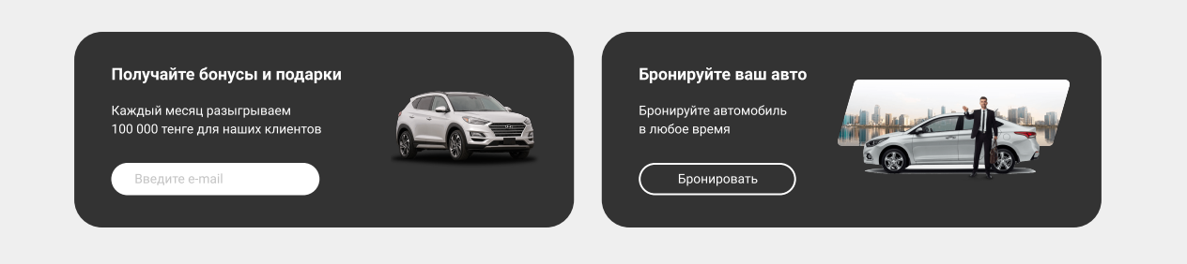

Next, we have a gallery of photos of luxury cars of the carousel type

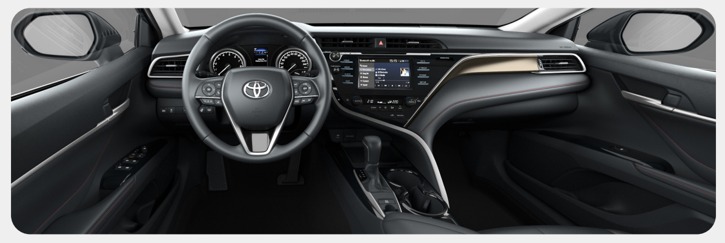

The cars that you have watched recently will be provided at the bottom.

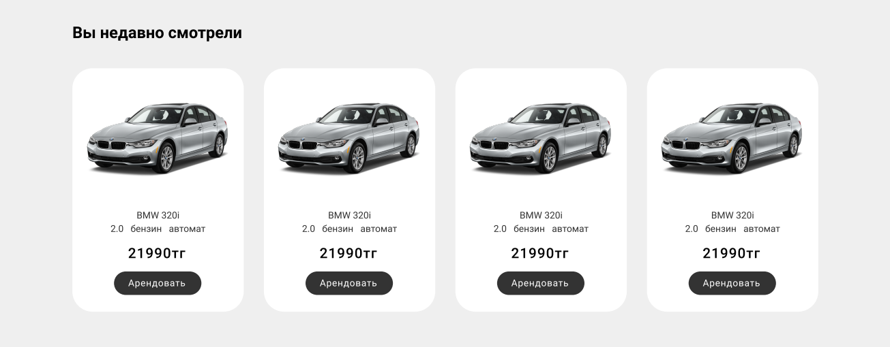

And at the end of the footer, I made an information list where Popular brands and business classes are shown. As well

as social networks and mail index , company address with contact (legal privacy policy).

